Q1. Explain the programming cycle for Python.
Ans.
- Python’s programming cycle is dramatically shorter than that of traditional programming cycle.
- In Python, there are no compile or link steps.
- Python code simply import modules at runtime and use the objects they contain.Because of this, Python code run immediately after changes are made.
- In cases where dynamic module reloading can be used, it is even possible to change and reload parts of a running program without stopping it at all.
- Fig. 1 shows Python’s impact on the programming cycle.
- Since Python is interpreted, there is a rapid turnaround after program changes. And because Python’s parser is embedded in Python-based systems, it is easy to modify code at runtime.
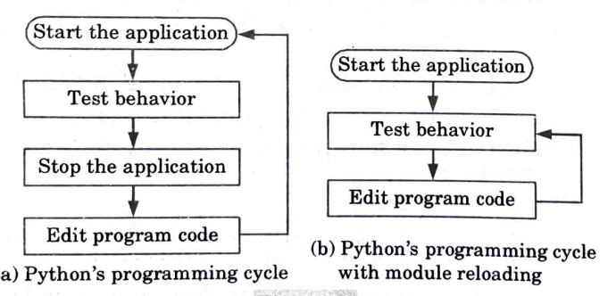

Q2. What is Python? How is Python interpreted? What are the tools that help to find bugs or perform static analysis? What Are Python decorators?
Ans.
Python: Python is a high-level, interpreted, interactive and object-oriented scripting language. It is a highly readable language. Unlike other programming languages, Python provides an interactive mode similar to that of a calculator.
Interpretation of Python :
- 1. An interpreter is a kind of program that executes other code.
- 2. When we write Python code, it converts source code written by the developer into an intermediate language which is again translated into the machine language that is executed.
- 3. The python code we write is compiled into python bytecode, which creates a file with the extension .pyc.
- 4. The bytecode compilation happened internally and was almost completely hidden from the developer.
- 5. Compilation is simply a translation step, and byte code is a lower-level, and platform-independent, representation of source code.
- 6. Each of the source statements is translated into a group of bytecode instructions. This bytecode translation is performed to speed execution. Bytecode can be run much quicker than the original source code
- statements.
- 7. The .pyc file, created in the compilation step, is then executed by appropriate virtual machines.
- 8. The Virtual Machine iterates through bytecode instructions, one by one, to carry out their operations.
- 9. The Virtual Machine is the runtime engine of Python and it is always present as part of the Python system, and is the component that actually runs the Python scripts.
- 10. It is the last step of the Python interpreter.
The following tools are the static analysis tools that help to find bugs in python :
1.Pychecker: Pychecker is an open source tool for static analysis that detects the bugs from source code and warns about the style and complexity of the bug.
2. Pylint:
- a.Pylint is highly configurable and it acts like special code to control warnings and errors, it is an extensive configuration file
- b. It is an open source tool for static code analysis and it looks for programming errors and is used for coding standard.
- c. It also integrates with Python IDEs such as Pycharm, Spyder, Eclipse, and Jupyter.
Python decorators:
- Decorators are very powerful and useful tool in Python since it allows programmers to modify the behavior of function or class.
- Decorators allow us to wrap another function in order to extend the behavior of wrapped function, without permanently modifying it.
- In decorators, functions are taken as the argument into another function and then called inside the wrapper function.
- Syntax :
@gfg_decorator
def hello_decorator():
print(“Gfg”)
- gfg_decorator is a callable function, will add some code on the top of some another callable function, hello_decorator function and return the wrapper function.

Q3. What do you mean by data types? Explain numeric and string data type with examples.
Ans.
Data types:
- The data stored in the memory can be of many types. For example, a person’s name is stored as an alphabetic value and his address is stored as an alphanumeric value.
- Python has six basic data types which are as follows:
  - Numeric
  - String
  - List
  - Tuple
  - Dictionary
  - Boolean
- Numeric
  - Numeric data can be broadly divided into integers and real numbers (i.e., fractional numbers). Integers can be positive or negative.
  - The real numbers or fractional numbers are called, floating point numbers in programming languages. Such floating point numbers contain a decimal and a fractional part.
For example:
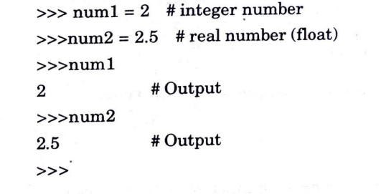
- String
  - Single quotes or double quotes are used to represent strings.
  - A string in Python can be a series or a sequence of alphabets, numerals and special characters.
  - For Example
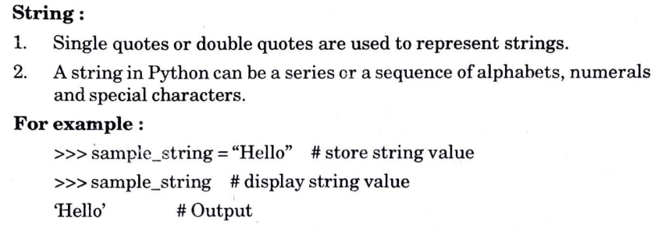

Q4. Discuss list and tuple data types in detail.
Ans.
List:
- A list can contain the same type of items.
- Alternatively, a list can also contain different types of items.
- A list is an ordered and indexable sequence.
- To declare a list in Python, we need to separate the items using commas and enclose them within square brackets ([ ]).
- Operations such as concatenation, repetition and sub-list are done on list using plus (+), asterisk (*) and slicing (:) operator.
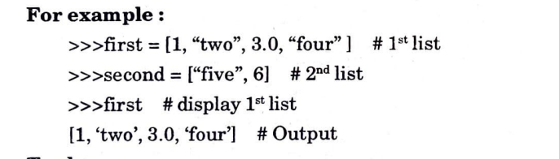
Tuple:
- A tuple is also used to store sequence of items.
- Like a list, a tuple consists of items separated by commas.
- Tuples are enclosed within parentheses rather than within square brackets.
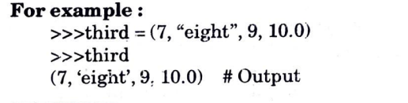

Q5. What do you mean by Boolean expression?
OR
Write short notes with example: The programming cycle for Python, elements of Python, type conversion in Python, operator precedence, and Boolean expression.
Ans.
Programming cycle for Python :
- Python’s programming cycle is dramatically shorter than that of traditional programming cycle.
- In Python, there are no compile or link steps.
- Python code simply import modules at runtime and use the objects they contain.Because of this, Python code run immediately after changes are made.
- In cases where dynamic module reloading can be used, it is even possible to change and reload parts of a running program without stopping it at all.
- Fig. 1 shows Python’s impact on the programming cycle.
Since Python is interpreted, there is a rapid turnaround after program changes. And because Python’s parser is embedded in Python-based systems, it is easy to modify code at runtime.
Elements of Python :
Data types:
- The data stored in the memory can be of many types. For example, a person’s name is stored as an alphabetic value and his address is stored as an alphanumeric value.
- Python has six basic data types which are as follows:
  - Numeric
  - String
  - List
  - Tuple
  - Dictionary
  - Boolean
- Numeric
  - Numeric data can be broadly divided into integers and real numbers (i.e., fractional numbers). Integers can be positive or negative.
  - The real numbers or fractional numbers are called, floating point numbers in programming languages. Such floating point numbers contain a decimal and a fractional part.
For example:
- String
  - Single quotes or double quotes are used to represent strings.
  - A string in Python can be a series or a sequence of alphabets, numerals and special characters.
  - For Example
List:
- A list can contain the same type of items.
- Alternatively, a list can also contain different types of items.
- A list is an ordered and indexable sequence.
- To declare a list in Python, we need to separate the items using commas and enclose them within square brackets ([ ]).
- Operations such as concatenation, repetition and sub-list are done on list using plus (+), asterisk (*) and slicing (:) operator.
Tuple:
- A tuple is also used to store sequence of items.
- Like a list, a tuple consists of items separated by commas.
- Tuples are enclosed within parentheses rather than within square brackets.
Dictionary:
- A Python dictionary is an unordered collection of key-value pairs.
- When we have the large amount of data, the dictionary data type is used.
- Keys and values can be of any type in a dictionary.
- Items in dictionary are enclosed in the curly-braces () and separated by the comma (,).
- A colon (:) is used to separate key from value. A key inside the square bracket [ ] is used for accessing the dictionary items.
- For example:
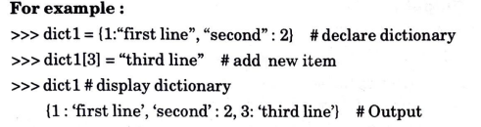
Boolean :
- 1. In a programming language, mostly data is stored in the form of alphanumeric but sometimes we need to store the data in the form of ‘Yes’ or ‘No’.
- 2. In terms of programming language, Yes is similar to True and No is similar to False.
- 3. This True and False data is known as Boolean data and the data types which stores this Boolean data are known as Boolean data types.
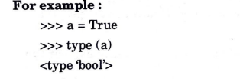
Type conversion in Python :
- 1. The process of converting one data type into another data type is known as type conversion.
- 2. There are mainly two types of type conversion methods in Python :
a. Implicit type conversion :
- When the data type conversion takes place during compilation or during the run time, then it called an implicit data type conversion.
- Python handles the implicit data type conversion, so we do not have to explicitly convert the data type into another data type
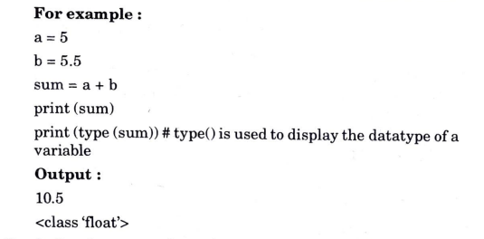
- In the given example, we have taken two variables of integer and float data types and added them.
- Further, we have declared another variable named ‘sum’ and stored the result of the addition in it.
- When we checked the data type of the sum variable, we can see that the data type of the sum variable has been automatically converted into the float data type by the Python compiler. This is called implicit type conversion.
b. Explicit type conversion:
- Explicit type conversion is also known as type casting.
- Explicit type conversion takes place when the programmer clearly and explicitly defines the variables in the program.
For example:
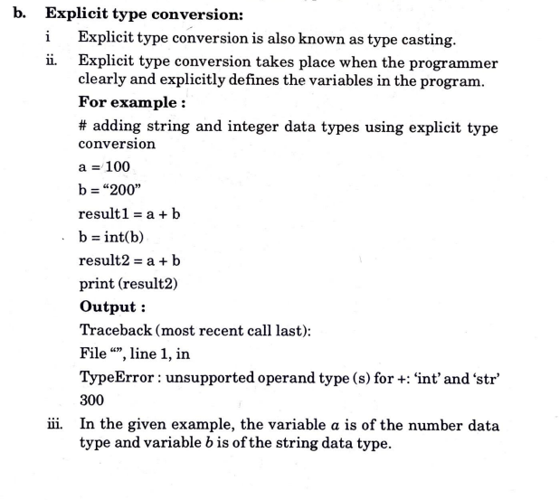
- In the given example, the variable a is of the number data type and variable b is of the string data type.
Operator precedence:
- 1. When an expression has two or more operator, we need to identify the correct sequence to evaluate these operators. This is because result of the expression changes depending on the precedence.
For example : Consider a mathematical expression: 10+ 5/5
When the given expression is evaluated left to right, the final answer becomes 3.
- 2. However, if the expression is evaluated right to left, the final answer becomes 11. This shows that changing the sequence in which the operators are evaluated in the given expression also changes the solution.
- 3. Precedence is the condition that specifies the importance of each operator relative to the other.
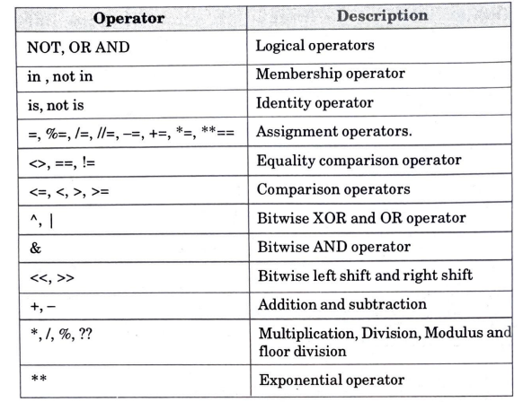
Boolean expression: A boolean expression may have only one of two values: True or False.
For example: In the given example comparison operator (==) is used which compares two operands and prints true if they are equal otherwise print false :
>>> 5 == 5
True #Output
>>> 5 == 6
False #Output

Q6. Explain elif statements in Python.
OR
Explain all the conditional statement in Python using small code example?
Ans. Different types of conditional statement are:
1. If statement:
1. An if statement consists of a Boolean expression followed by one or more statements.
2. With an if clause, a condition is provided; if the condition is true then the block of statement written in the if clause will be executed, otherwise not.
3. Syntax:
If (Boolean expression): Block of code #Set of statements to execute if the condition is true
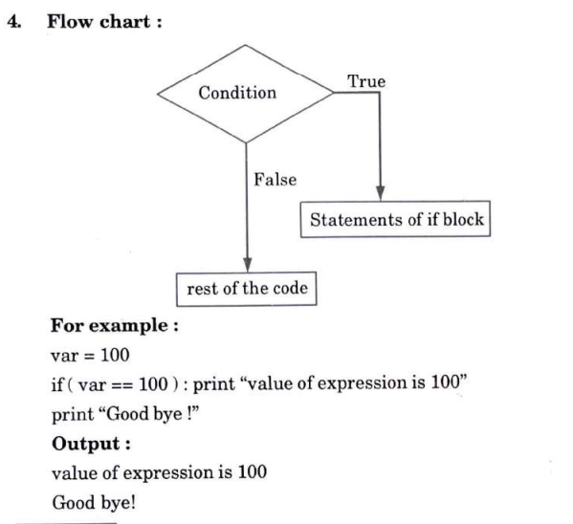
2. If else statement:
1.An if statement can be followed by an optional else statement, which executes when the Boolean expression is False.
2. The else condition is used when we have to judge one statement on the
basis of other.
3. Syntax: If (Boolean expression): Block of code #Set of statements to execute – if condition is true
else: Block of code #Set of statements to execute if condition is false
4. Working and execution:
- The condition will be evaluated to a Boolean expression (true or false).
- If the condition is true then the statements or program present inside the if block will be executed
- If the condition is false then the statements or program present inside else block will be executed.
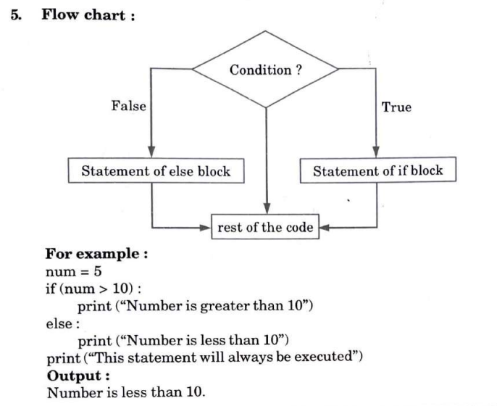
3.Nested-if statement:
- Nested-if statements are nested inside other if statements. That is, a nested-if statement is the body of another if statement.
- We use nested if statements when we need to check secondary conditions only if the fist condition executes as true.
- 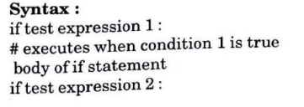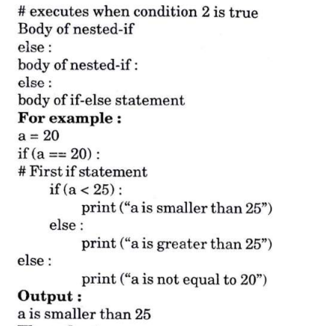
- 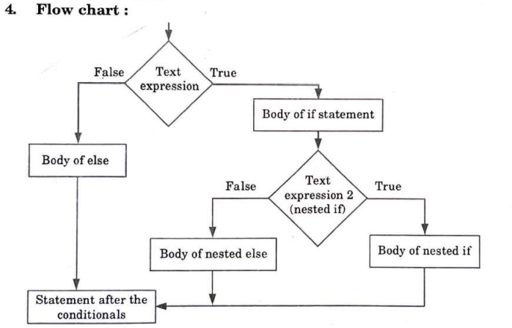
4. Elif statement:
- Elif stands for else if in Python.
- We use elif statements when we need to check multiple conditions only if the given if condition executes as false.
- Working and execution:
  - If the first if condition is true, the program will execute the body of the if statement. Otherwise, the program will go to the elif block (else if in Python) which basically checks for another if statement.
  - Again, if the condition is true, the program will execute the body of the elif statement, and if the condition is found to be false, the program will go to the next else block and execute the body of the else block.
- Syntax
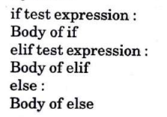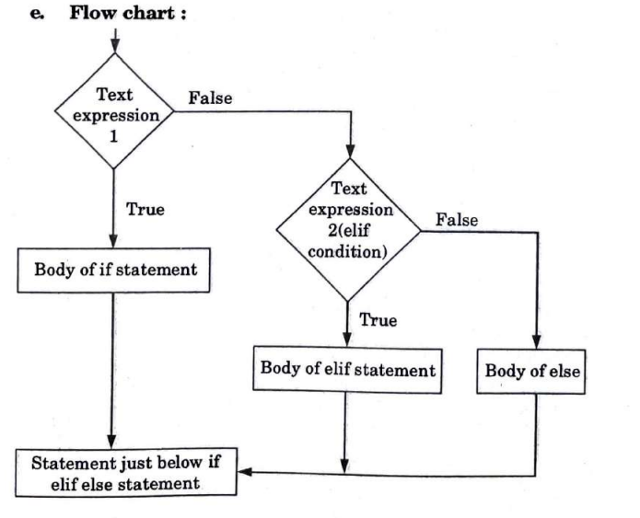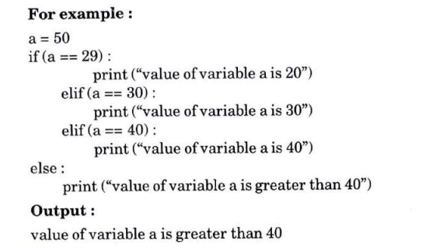

Q7. Explain expression evaluation and float representation with example. Write a Python program for how to check if a given number is Fibonacci number.
Ans. Expression evaluation:
- In Python actions are performed in two forms:
  - Expression evaluation,
  - Statement execution.
- The key difference between these two forms is that expression evaluation returns a value whereas statement execution does not return any value.
- A Python program contains one or more statements. A statement contains zero or more expressions.
- Python executes a statement by evaluating its expressions to values one by one.
- Python evaluates an expression by evaluating the sub-expressions and substituting their values.
- For example:
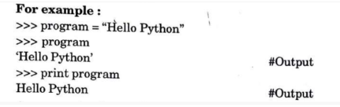
- An expression is not always a mathematical expression in Python. A value by itself is a simple expression, and so is a variable.
- In the given example, we assigned a value “Hello Python” to the variable program. Now, when we type only program, we get the output ‘Hello Python’. This is the term we typed when we assigned a value to the variable. When we use a print statement with program it gives the value of the variable i.e., the value after removing quotes.
Float representation:
- Floating point representations vary from machine to machine.
- The float type in Python represents the floating-point number.
- Float is used to represent real numbers and is written with a decimal point dividing the integer and fractional parts.
- For example: 97.98, 32.3+e18, -32.54e100 all are floating point numbers.
- Python float values are represented as 64-bit double-precision values. The maximum value any floating-point number can be is approx 1.8 × 10308
- Any number greater than this will be indicated by the string inf in Python.
- Floating-point numbers are represented in computer hardware as base 2 (binary) fractions.
- For example, the decimal fraction 0.125 has value 1/10+2/100+ 5/1000, and in the same way the binary fraction 0.001 has value 0/2 + 0/4 + 1/8.
- For example: # Python code to demonstrate float values.
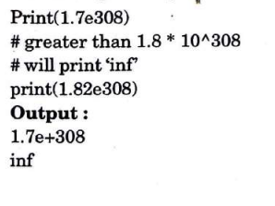
Program:
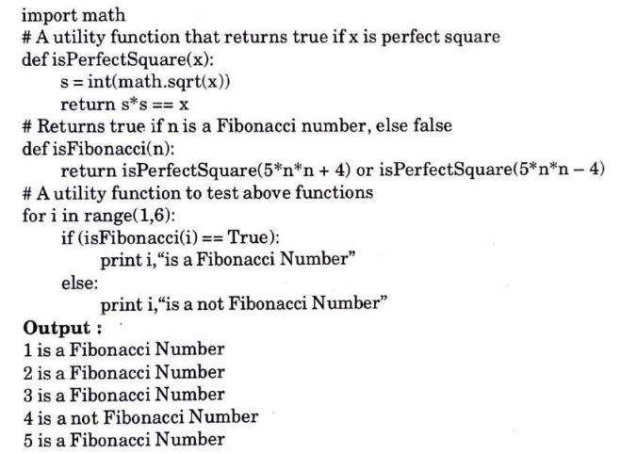

Q8. Explain the purpose and working of loops. Discuss break and continue with examples. Write a Python program to convert time from 12 hour to 24-hour format.
Ans.
Purpose and working of loops :
- A loop is a programming structure that repeats a sequence of instructions until a specific condition is met.
- A loop statement allows us to execute a statement or group of statements multiple times.
  - a. For
  - b. While
  - C.Nested
- Python programming language provides following types of loops to handle looping requirements:
- Purpose: The purpose of loops is to repeat the same, or similar, code a number of times. This number of times could be specified to a certain number, or the number of times could be dictated by a certain condition being met.
- Working: Consider the flow chart for a loop execution:
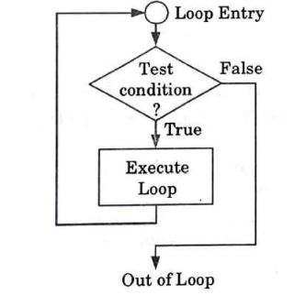
  - In the flow chart if the test condition is true, then the loop is executed, and if it is false then the execution breaks out of the loop.
  - After the loop is successfully executed the execution again starts from the loop entry and again checks for the test condition, and this keeps on repeating until the condition is false.
Break statement:
- The break keyword terminates the loop and transfers the control to the end of the loop.
- While loops, for loops can also be prematurely terminated using the break statement.
- The break statement exits from the loop and transfers the execution from the loop to the statement that is immediately following the loop.
- For example:
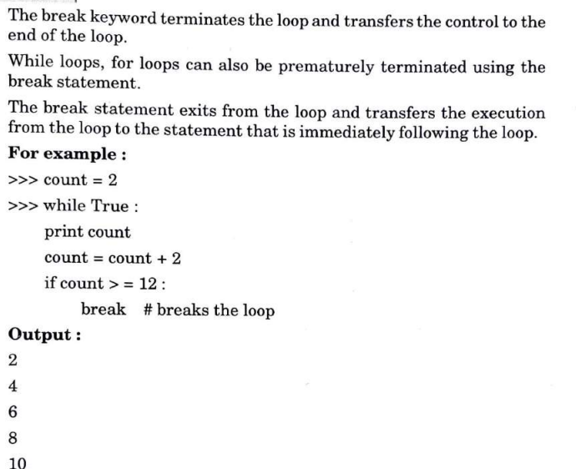
Continue statement:
- The continue statement causes execution to immediately continue at the start of the loop, it skips the execution of the remaining body part of the loop.
- The continue keyword terminates the ongoing iteration and transfers the control to the top of the loop and the loop condition is evaluated again. If the condition is true, then the next iteration takes place.
- Just as with while loops, the continue statement can also be used in Python for loops
- For Example:
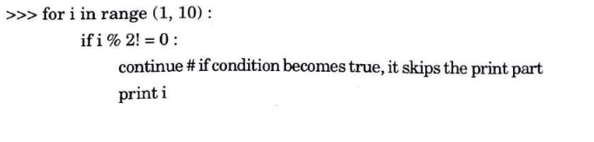
Output
- 2
- 4
- 6
- 8
Program:
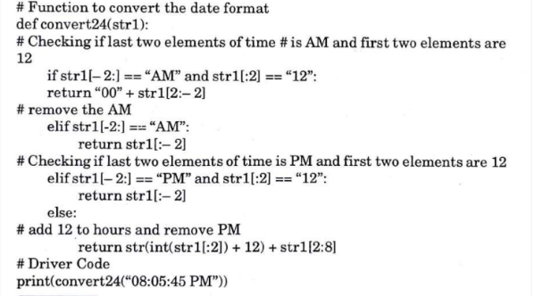

Q9. Differentiate between for and while loop.
Ans.
Properties | For | While
Format | Initialization, condition checking, iteration statements are written at the top of the loop. | Only initialization and condition checking is done at top of the loop
Use | The ‘For’ loop is used only when we already knew the number of iterations | The ‘while’ loop is used only when the number of iterations are ot exactly known.
Condition | If the condition is not given in the ‘for’ loop then the loop iterates infinite times. | If the condition is not given in the ‘while’ loop, it provides compilation error.
Initialization | In ‘for’ loop the initialization once done is never repeated. | In the ‘while’ loop if initialization is done during condition checking, then initialization is done each time the loop iterates.

