JoSAA Information Assistant

An intelligent, multi-tool agent that delivers precise and explainable answers about IIT programs, JoSAA opening and closing ranks, curriculum details, department information, and NIRF rankings — all powered by an LLM-based reasoning pipeline and a fully customized Gradio interface.

The JoSAA Information Assistant simplifies academic and admission-related queries for IIT aspirants by combining intent detection, multi-step reasoning, and tool-based retrieval with a modern, user-friendly UI.

The system seamlessly integrates data from multiple sources: curriculum from PDFs, rank information from Excel sheets, department details from documents, and NIRF rankings from web sources — unifying them into a single, coherent answering platform.

Track Tags

building-mcp-track-consumer
mcp-in-action-track-consumer

Team Members (Huggingface Ids):
- kishanraos
- Srijaa07
- Haswal0404
- NeerajAhire
- shivbaba0987

Social Media Post:
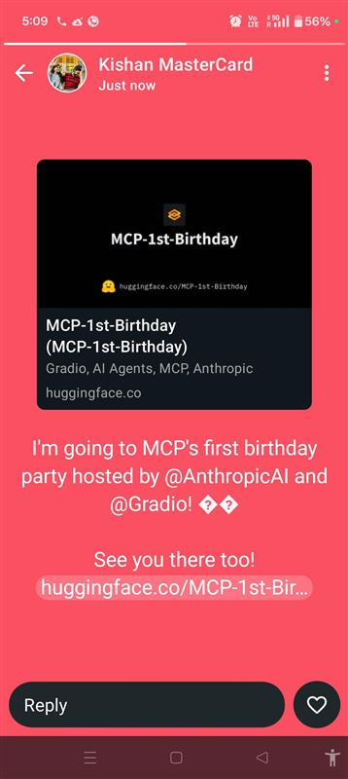

Setup & Installation:
- Clone the repository
- git clone <repo-url>
- cd josaa-information-assistant
- Install dependencies
- pip install -r requirements.txt
- python3 chat_app.py
- python3 mcp_server.py
- Open the Gradio UI in your browser.

Features:
Tools | Purpose
Excel Analyzer | Fetches JoSAA opening/closing ranks from structured Excel sheets.
PDF Reader | Reads multi-page IIT curriculum PDFs and extracts semester-wise subjects & credits.
Webpage Parser | Scrapes official links for alumni details, NIRF data, general info.

Agent/Other Utility | Purpose
LangGraph Architecture | Graph-based framework for building stateful, multi-agent workflows where nodes represent agents or tools and edges define message-passing for dynamic, asynchronous execution.
Intent Detection | Classifies user queries into:  - Out of Scope  - Basic Chit Chat  - In Scope
Query Splitting | Breaks multi-part questions into small, tool-executable chunks.
Dependency Resolution | If one tool output is required for another, the agent passes context automatically. Also tasks are executed in order.
Tool Planning | Once the query is broken down into most granular form, planner considers whether to fetch info from excel, pdfs or web links.
Unified Synthesizing | Used for integrating the multiple answers to a single structured one
Incomplete Question Enhancing via chat history | The chat history is recorded and if some incomplete questions are dependent on chat history, then the history is fetched and relevant context is appended to make the question complete.
UI Integration (Gradio 6) | Fully custom interface with chat history, sessions, sliders, dropdowns, dark theme, and integrated tool results inside chat.  - Two-panel layout (sidebar + chat window), multi-session management  - New session creation, Custom sliders, dropdowns, reset icons  - Full dark theme, Chat-integrated tool responses
MCP Server for data resources | Exposing relevant data sources like course details, rank cutoffs, alumni details etc

Query Graph:

